📊 EURCHF (H1) — Decision
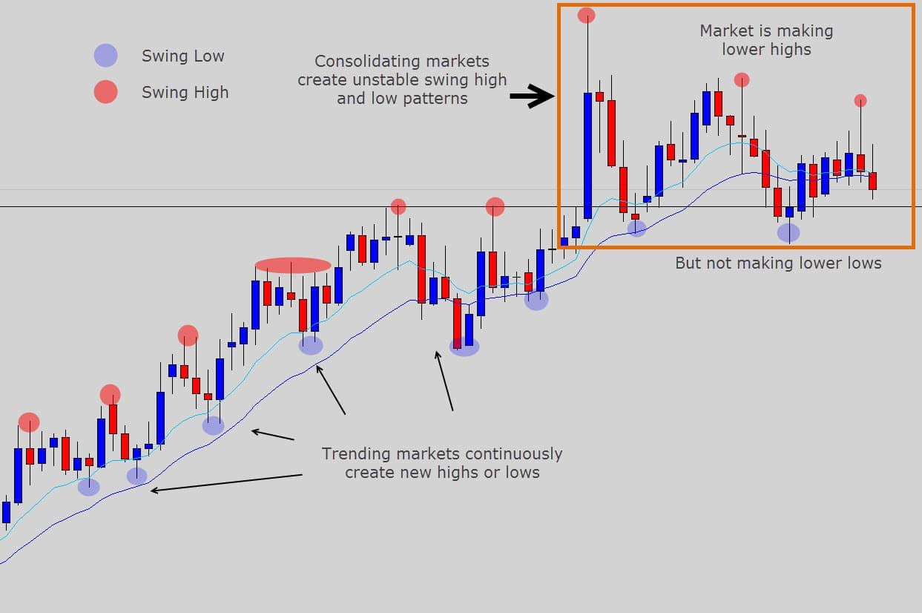
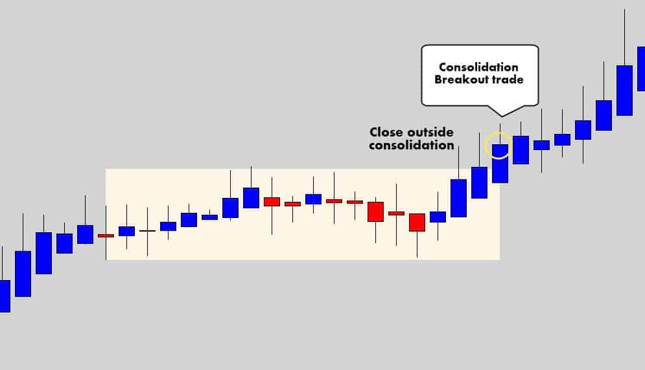
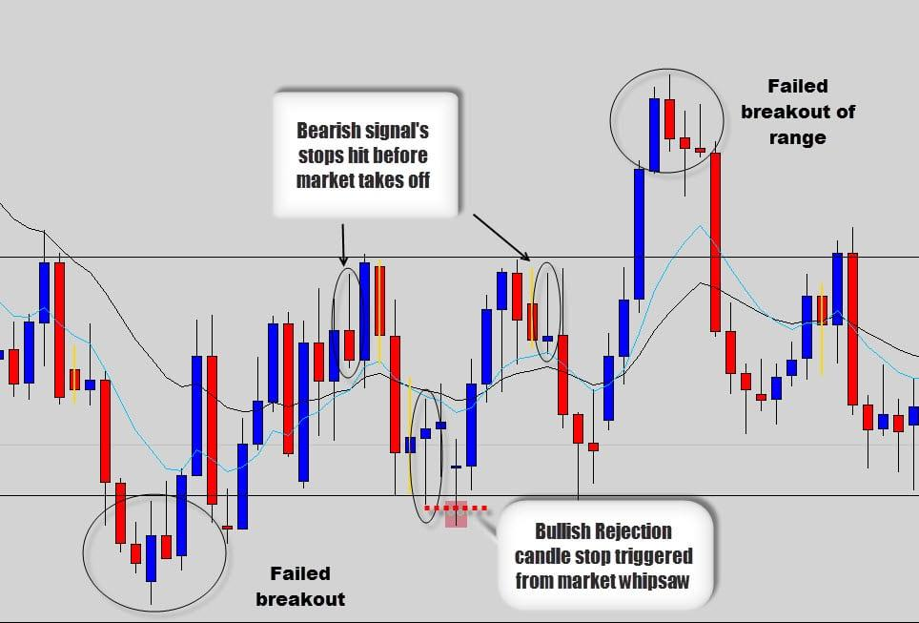
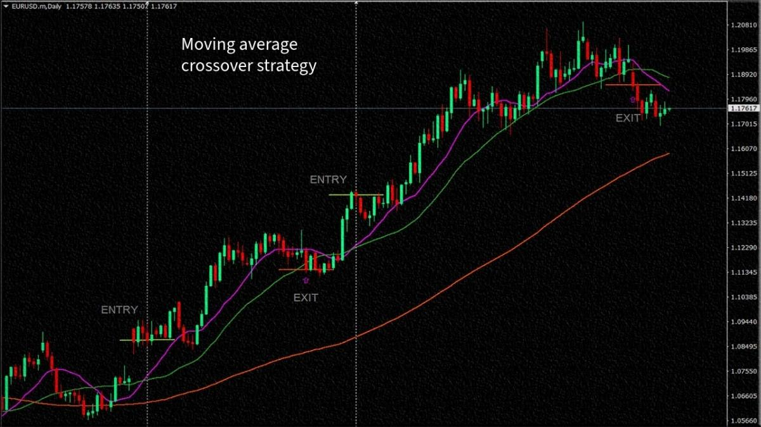
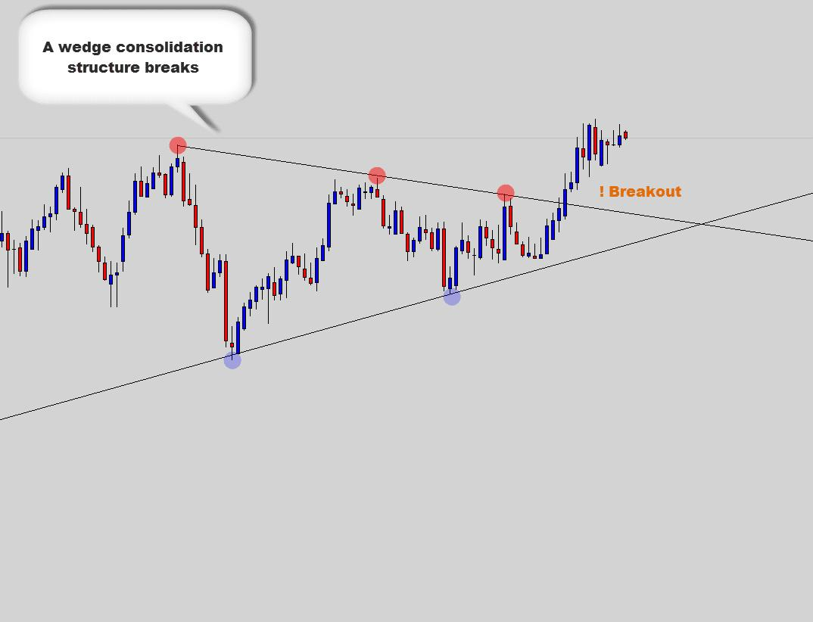
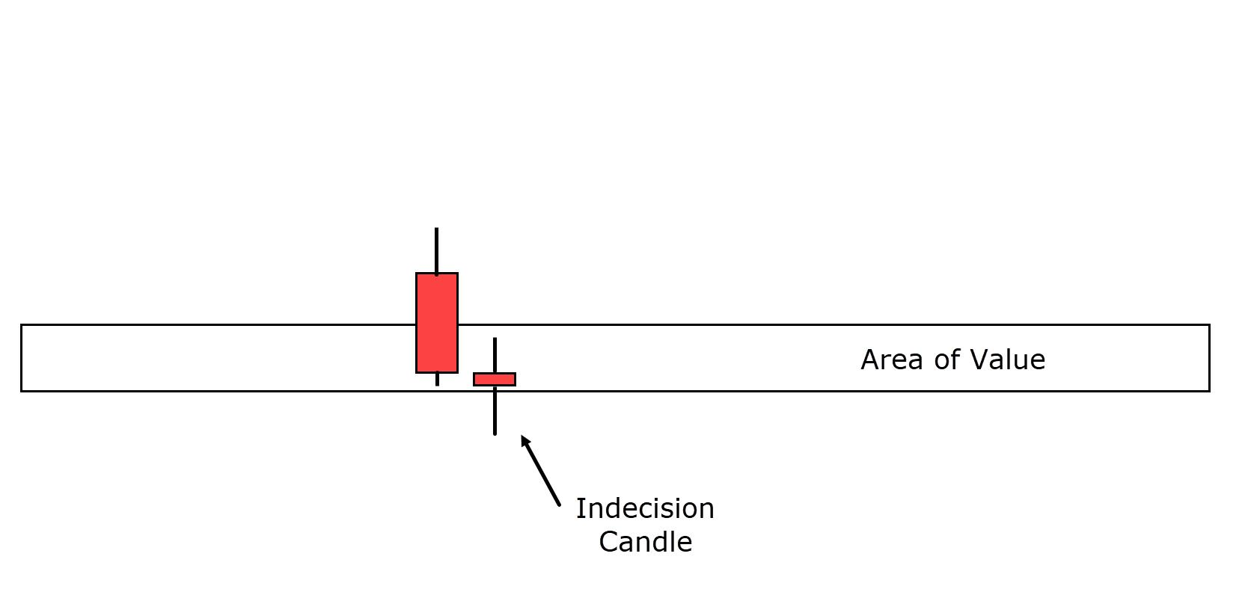

🔍 What I’m Seeing
- Market was trending up, but now…
- Price is slowing down / consolidating
- Candles are smaller + mixed (indecision)
- Price is around EMA 50
- EMA 50 is just above EMA 200 (weak trend, not strong)
👉 This is NOT a clean trend anymore

⚠️ Key Insight
This is a transition zone:
- Not strong enough to confidently BUY
- Not weak enough to SELL
👉 This is where most traders lose money (choppy market)

🎯 Smart Decision

❌ Best Move Right Now:
👉 NO TRADE

🟢 When to BUY
Only if:
- Price breaks above recent high
- Strong bullish candles return
- Price holds above EMA 50

🔴 When to SELL
Only if:
- Price drops below EMA 200
- Clear lower low forms
- EMA 50 starts sloping down

🧠 EA Perspective
Your bot should:
- ❌ Avoid trading here
- ✅ Wait for:
  - Breakout OR
  - Strong trend confirmation

🔥 Final Answer
👉 Decision: NO TRADE
👉 Reason: Market is ranging / indecisive

If you want next:
I can modify your EA to automatically detect and avoid sideways markets (this is a huge win-rate booster).

